WASH IN SCHOOLS MONITORING SYSTEM

For WinS Program Management

ADMINISTRATOR’S MANUAL FOR THE SCHOOLS DIVISION IT OFFICER

- INTRODUCTION

This manual is intended for the Division IT Officer. It contains instructions to Manage User Accounts, Manage the Masterlist of Schools, Finalize School Data, Enter Validation Results, and Generate Results.
The WinS Monitoring System is composed of the paper-based WinS Monitoring Form which will be accomplished by the schools, the Excel-Based WinS Monitoring System which will be used to encode data from the monitoring form, and the WinS Online Monitoring System which will be used to upload the data from the Excel-Based System and generate aggregated reports for use in the Division, Region and National Levels. These are discussed in more detail in the User’s Manual for Schools.
The latest versions of the Monitoring Form, Excel-Based System and Online Monitoring System can be accessed at http://deped-wins.sysdb.site.

- WINS ONLINE MONITORING SYSTEM

The online monitoring system can be accessed at http://deped-wins.sysdb.site. It was designed primarily to upload the Excel-Based System that was encoded by the schools and generate aggregated reports that will be useful to the Divisions, Regions and National levels. It also has system administration modules to manage the user accounts and masterlist of schools.

- Logging in
Accessing the website will bring the user to the Login Page. The Division IT Officer has to enter the appropriate username and password to access the administrator modules of the system. The username and password of the divisions will be maintained by the Regional IT Officer. Please contact your respective Regional IT Officer if you still do not have a user account.
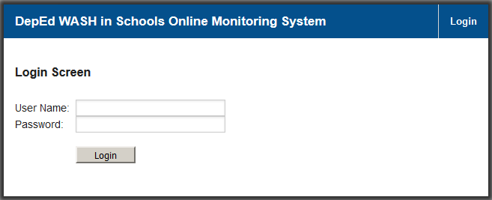

- Managing the Masterlist of Schools

This module allows the administrator to add new schools and edit existing ones. There is no facility to delete schools. Move the mouse to the <Settings> Menu in the upper right section of the screen, then click the <Manage Schools> command to access the Search Schools Screen.

Click on the <Add New> button in the Search School Screen to access the Add School Screen.
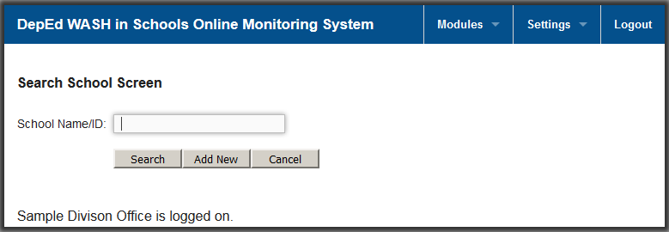
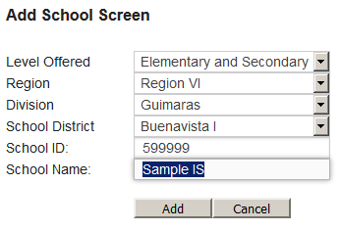
Enter the appropriate data then click on the <Save> button to update the database. Please make sure the data is consistent with the Basic Education Information System (BEIS).

If the school is an integrated school with a single School ID for both elementary and secondary level, set the <Level Offered> dropdown to “Elementary and Secondary” then fill in the appropriate data in the rest of the fields.
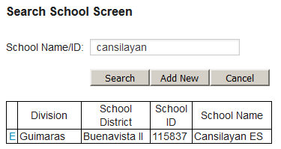
In order to modify the data for an existing school, go to the Search School Screen by clicking on the <Manage Schools> command found in the <Settings> Menu. Enter the school then click on <Search> to display a list of schools matching the search criteria. Click on the <E> Edit command found in the first column beside the Division to access the Edit School Screen.
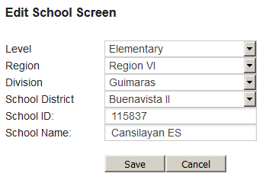
Make the necessary revisions then click on the <Save> button to update the database.

- Managing User Accounts
This module allows the administrator to add, edit and delete user accounts. Move the mouse to the <Settings> Menu in the upper right section of the screen, then click the <Manage Users> command to access the Search User Screen.

Click on the <Add New> button in the Search User Screen to access the Add User Screen.
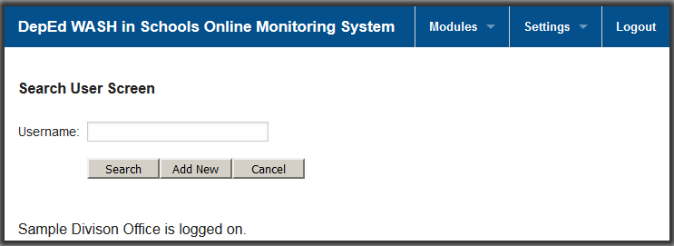

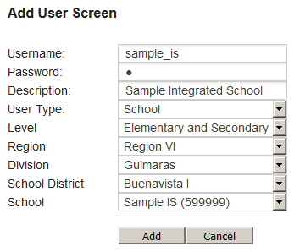
Enter the appropriate data for the user then click on the <Save> button to update the database. The Division IT Officer is authorized to create user accounts for the division, school districts and schools under its jurisdiction.

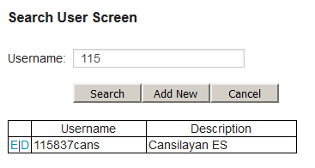
If the school is an integrated school with a single School ID for both elementary and secondary level, set the <Level > dropdown to “Elementary and Secondary”. This will result in the school dropdown displaying only integrated schools with a single School ID. Fill in the appropriate data in the rest of the fields and click save.
In order to modify the data for an existing user account, go to the Search User Screen by clicking on the <Manage Users> command found in the <Settings> Menu. Enter the username then click on <Search> to display a list of usernames matching the search criteria. Click on the <E> Edit command found in the first column beside the username to access the Edit User Screen.

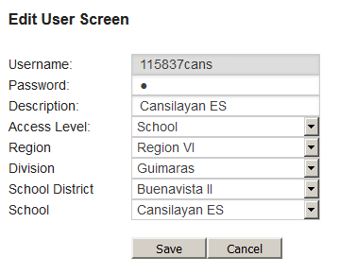
Make the necessary revisions then click on the <Save> button to update the database.

In order to delete an existing user account, go to the Search User Screen and search for the username that will be deleted. Click on the <D> Delete command found in the first column beside the username to access the Delete User Screen.

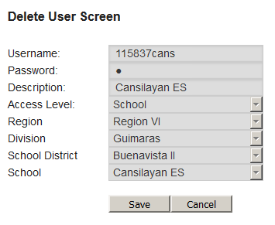
Click on the <Save> button to delete the user account.

- Closing Schools

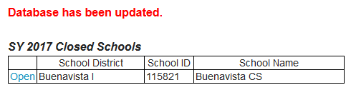
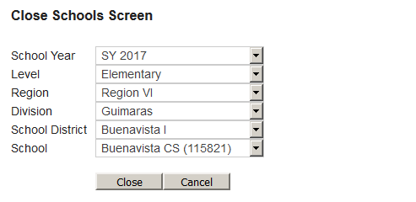
This module allows the administrator to close a particular school for a particular school year so the said school will no longer be counted in the status report. Move the mouse to the <Settings> Menu in the upper right section of the screen, then click the <Close Schools> command to access the Close Schools Screen. Select the school that will be closed and click on the <Close> button. The table in the lower section of the screen will list all the closed schools in the division for the school year selected. To reopen a closed school simply click on the <Open> command in the first column of the table.
- Finalizing school data
This module allows the administrator to finalize the data for schools under their jurisdiction. Move the mouse to the <Modules> Menu in the upper right section of the screen, then click the <Finalize Data> command to access the Finalize Data Screen. Select the appropriate school and set the Finalize Data dropdown to “Yes” to lock the data of the school. The whole division can be finalized by leaving the dropdown for School District and School blank.

If a school has been “finalized”, a message preventing the user from changing the data will appear in the Upload School System Screen.

- Entering results of validation activities
This module allows the administrator or a division user to enter the results of validation activities. Move the mouse to the <Modules> Menu in the upper right section of the screen, then click the <Validation Findings> command to access the Add Validation Findings Screen.

Select the school being validated and indicate the issues found if any in the Remarks textbox.
The table in the bottom section of the Add Validation Findings Screen will be updated with the findings that were recorded. To Edit a record, click on the <E> command and to Delete, click on the <D> command beside the Date column.
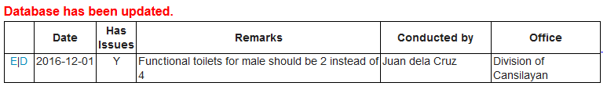

- Generating reports

This module allows the user to generate the various reports that the system can produce. Click on the <Generate Reports> command found in the <Modules> Menu to access the Generate Reports Screen. The reports can be summarized by Region, Division, School District or School by adjusting the <Summarize by> dropdown. Set the <Show Schools> dropdown to “No” if you want the system to generate summaries. Set the <Show Schools> dropdown to “Yes” if you want to see the school data. Click on the Reports found in the lower section of the screen to generate the report.
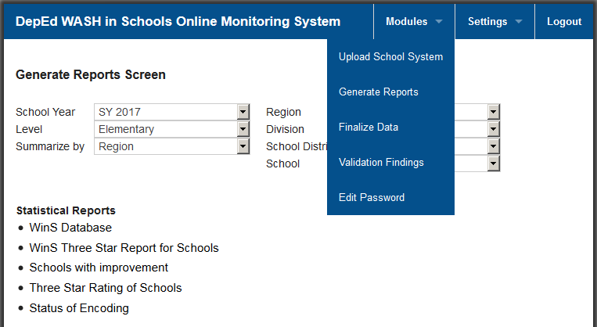

The system can currently generate the following reports:
- WinS Database – Generates the whole database for all schools
- WinS 3-Star Report for Schools – Generates the rating of the school for each indicator
- Schools with Improvement – Generates the schools which were able to improve their star rating from the previous school year
- Three Star Rating of Schools – Generates the star rating of all schools
- Status of Encoding – Generates the status of schools which have encoded data for the school year

- Helpdesk
For inquiries regarding the system please contact deped.wins.help@gmail.com.

